Welcome to the

RAPID (R) 1.0

Help Document

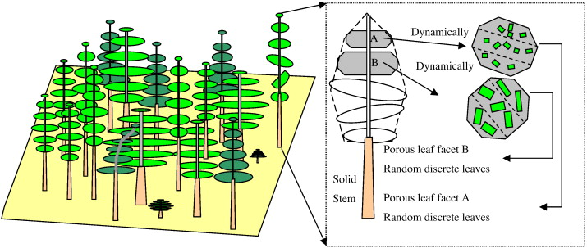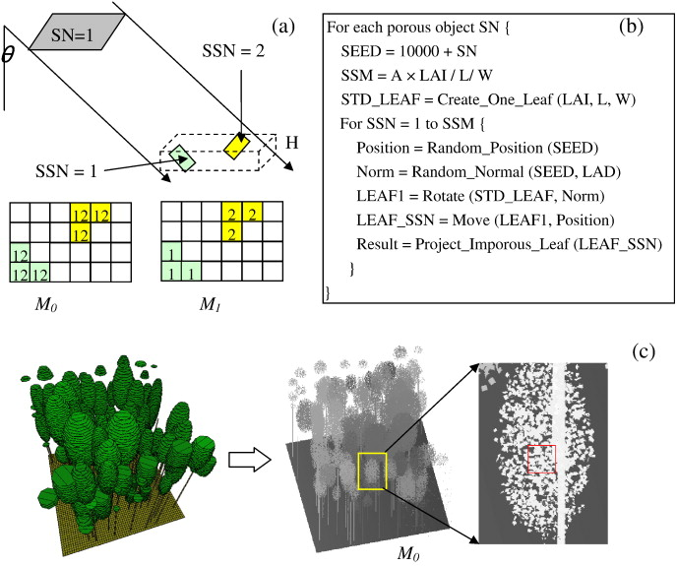

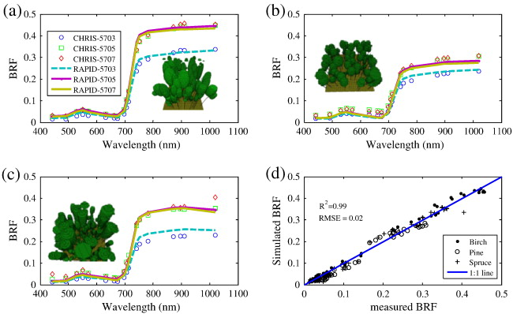

Author: Huaguo Huang
Email: huaguo.huang@gmail.com
huaguo_huang@bjfu.edu.cn
Version 1.0 from April 2013
Contents

1.General Introduction 3
1.1 What is RAPID? 3
1.2 Overview RAPID Interface 3
1.3 Overview Data/File Structure 3
2. RAPID Input and Output Files 4
2.1. Input Files 4
2.2 Output Files 7
3.Structure file generation 12
3.1 interactive editing 12
3.2 Automatic generation using Matlab 12
4. Temperature file generation 15
5. Model Run 15
6. Visualization of RAPID results using RGM Displayer 19

1.General Introduction

1.1 What is RAPID?
RAPID is a radiosity-based remote sensing simulator in optical range for directional reflectance, temperature and lidar signals of vegetation-involved 3D scenes. RAPID is based on previous studies of RGM (Qin and Gerstl, 2000) and TRGM (Liu et al., 2007).

1.2 Overview RAPID Interface
RAPID is basically a suite of DOS programs. A mixed-language-approach is used including Fortran, C and C++. A MFC-based interface is developed to make users to use these DOS programs easier. OpenGL is used to visualize the simulated results. The main purpose of the interface is to load the input files and start your simulations. The user will not spend a lot of time working with the RAPID interface itself. A simplest notepad editor is provided for your editing if you know the specific file format (you can find out in this document).

1.3 Overview Data/File Structure
The programs are organized as follows:
+Root directory
+Bin-----------------------------------------------------------------Binary directory
RGMDisp.exe------------------------------------------------RAPID interface
+run------------------------------------------------------------------DOS programs
ref.exe----------------------------------------------------to calculate view factor, BRF, DBT
img.exe----------------------------------------------------to calculate BRF at large FOV
mer.exe----------------------------------------------------Merge hash tables
sol.exe-----------------------------------------------------solve multiple scattering
runtir.bat--------------------------------------------------Batch file to run the DOS programs
POLY.IN-----------------------------------------------------3D structure file
optics.in------------------------------------------------spectral file
ref.in----------------------------------------------------sun and sky file
sensor.in-----------------------------------------------sensor spectral response file
soil.in--------------------------------------------------soil patch number (optional)
thermal.in---------------------------------------------temperature field from SVAT (Ecupid)
+ecupid--------------------------------------------------------SVAT program of Ecupid
CUPID_INPUT_SIMPLE.xls--------------------Cupid interface
Ecupid.exe----------------------------------------------Ecupid main program
c6.filist --------------------------------------------------Ecupid configure file
+Examples----------------------------------------------Ecupid demonstration cases
+Help----------------------------------------------------------Help documents
Help.pdf------------------------------------------------this document
+SourceCode------------------------------------------------- All source codes
+EcupidV2---------------------------------------------Ecupid
+RGMDisp---------------------------------------------Interface
+TRGM-------------------------------------------------TRGM
+RAPID-------------------------------------------------RAPID

2. RAPID Input and Output Files

2.1. Input Files
A. Overview of Files
The input files are not integrated into a big configuration file. Instead, a few separate files are defined for different information. Main input files include: POLY.IN, REF.IN, OPTICS.IN,VIEWBIDIR.DAT, TC.IN.

B. 3D Structure file – POLY.IN
POLY.IN is one of the key files when working with RAPID. It stores the coordinates and colors of a large number of triangles and rectangles. Each triangle or rectangle belongs to a plant, soil, or other objects. An example of POLY.IN is shown in Fig. 1:
Fig. 1 POLY.IN file format example
10.00 (scene width)
10.00 (scene length)
2 (has only two polygons)
4 0 0.5 0 0.5 0 0.1 0 0 0 0 0 0 0 1 (polygon 1 with four vertexes)
0.000000 0.000000 0.000000 (X Y Z of the first vertex)
0.500000 0.000000 0.000000 (X Y Z of the second vertex)
0.500000 0.500000 0.000000 (X Y Z of the third vertex)
0.000000 0.500000 0.000000 (X Y Z of the fourth vertex)
4 0 0.06 0 0.5 0 0.06 0 0.38 0 1.4 0.3 0.2 0 2 (polygon 2 with four vertexes)
6.108565 8.441255 12.343750 (X Y Z of the first vertex)
6.345514 7.386700 12.343750 (X Y Z of the second vertex)
7.326827 8.078005 12.343750 (X Y Z of the third vertex)
7.291285 8.236188 12.343750 (X Y Z of the fourth vertex)
The first two lines describe the scene width and length. The third line gives how many polygons stored in this file. From the fourth line to the end, polygons are stored one by one. The first polygon is a soil rectangle with vertexes 4, not hiding (0), red reflectance (0.5), red transmittance (0), green reflectance (0.5), green transmittance (0), blue reflectance (0.1), blue transmittance (0), leaf area index (0), not needle leaf (0), polygon radius (none), polygon thickness (0), leaf size (none), reservation field (0), and sequence number (1). The second polygon is a porous leaf rectangle with vertexes 4, not hiding (0), red reflectance (0.06), red transmittance (0), green reflectance (0.5), green transmittance (0), blue reflectance (0.06), blue transmittance (0), leaf area index (0.38), not needle leaf (0), polygon radius (1.4), polygon thickness (0.3), leaf size (0.2), reservation field (0), and sequence number (2).

Fig. 2 the visualization of polygongs in POLY.IN

POLY.IN files may be generated by manual editing. However, it is very time consuming. Therefore, we provide a few methods for users to generate POLY.IN interactively or automatically. Please see next section for detail.

Note: This POLY.IN is compatible with that of RGM. The difference is the porous feature with additional information such as leaf area index, patch size and leaf size.

C. Component spectral files – optics.in and optics.cat
3 4 1.0 (3 components <leaf, stem, soil>, 4 bands, zoom coefficient)
wavelen 670 792 8000 10000 (wavelength of the four bands)
leaf
0.08 0.50 0.02 0.02 (reflectances of “leaf” in four bands)
0.07 0.40 0 0 (transmittances of “leaf” in four bands)
stem
0.08 0.50 0.02 0.02 (reflectances of “stem” in four bands)
0.00 0.00 0 0 (transmittances of “stem” in four bands)
soil
0.09 0.20 0.05 0.05 (reflectance of “soil” in four bands)
0 0 0 0 (transmittances of “soil” in four bands)
This file, optics.in, tells the reflectance and transmittance of all the components in POLY.IN. The file optics.cat has the same structure and component sequence of optics.in. The only difference for optics.cat from optics.in is that “optics.cat” must have only three bands, RGB, and should be the same reflectance and transmittance as the RGB in POLY.IN.

C. Component LAD files – leaf_lad.in
This file tells users the leaf angle distribution of all the components in POLY.IN. The file has the similar structure and component sequence to optics.in. The difference is that wavelength and corresponding reflectance or transmittance are replaced by angles and fractions.
5 18 1.0 (five components, 18 angles, zoom coefficient)
angles 5 10 15 20 25 30 35 40 45 50 55 60 65 70 75 80 85 90
leaf_birch
0.0000 0.0006 0.0547 0.0431 0.0351 0.0257 0.0243 0.054 0.0563 0.0847 0.1066 0.0863 0.0727 0.0716 0.0679 0.069 0.0744 0.0731
leaf_alder
0.0027 0.0113 0.0226 0.0296 0.0404 0.0494 0.0561 0.0567 0.0553 0.0664 0.0728 0.0749 0.0784 0.0725 0.0745 0.0773 0.078 0.0812
leaf_aspen
0.0027 0.0143 0.0257 0.0368 0.0472 0.0529 0.0592 0.0771 0.0725 0.0683 0.0732 0.0681 0.0715 0.0664 0.0688 0.0651 0.0658 0.0643
leaf_pine
0.0056 0.0232 0.0356 0.0283 0.0369 0.0413 0.0489 0.0483 0.0472 0.0494 0.0566 0.0585 0.0697 0.0763 0.0898 0.0973 0.0925 0.0946
leaf_spruce
0.0056 0.0232 0.0356 0.0283 0.0369 0.0413 0.0489 0.0483 0.0472 0.0494 0.0566 0.0585 0.0697 0.0763 0.0898 0.0973 0.0925 0.0946
D. Sun and sky files – ref.in
38.68 162.98 (sun zenith, sun azimuth)
40 (sky hemisphere division number)
0.1 0.1 1.0 1.0 0 0 (diffuse light fraction)
1 1 10 10 1 1 (total incident radiation)
1.3 (f, iteration coefficient)
0.00001 300 (epsilon, No. of iterations to quit
0 a
0 b
0.0 specular ON/OFF
0 specular ON/OFF
1.35 refractive index
5. Phong's constant
This file tells users the incident radiation information. The first line shows the sun position. Then, the sky is divided into 40 equal sections. The total incident radiation in each wavelength (same to the that in optics.in) is added in line 4. The line 3 shows the diffuse fraction in the total radiation. The other lines are not so important except the specular switch to determine if non-diffuse assumption is accepted.

E. The sensor files – viewbidir.dat
0 0.002 c (FOV, epsilon threshold, and soil BRDF parameter)
4 (view angle numbers)
80 0 (first view zenith and azimuth)
70 60 (second view zenith and azimuth)
60 90 (third view zenith and azimuth)
50 180 (last view zenith and azimuth)
This file defines the sensor field of view (FOV) and all view angles. The soil BRDF parameters defines how the soil BRF is corrected if the “specular” switch in “ref.in” is on. If the soil BRDF parameter is “c”, soil BRF is generated by intrinsic BRF models. If “m”, soil BRF will only be corrected by measured soil BRF.

F. Vegetation and soil temperature file – tc.in
3 2 1.0 (three components, two layers, zoom coefficient)
layer 1 2 (Layer id)
leaf
25.5 25.5 (sunlit temperatures for layer 1 and 2)
23.8 23.8 (shaded temperatures for layer 1 and 2)
stem
20 20 (sunlit temperatures for layer 1 and 2)
18 18 (shaded temperatures for layer 1 and 2)
soil
28 28 (sunlit temperatures for layer 1 and 2)
23 23 (shaded temperatures for layer 1 and 2)
This file stores the component temperature at different layers. The temperatures can be assigned manually, but we strongly suggest to use SVAT models (e.g. CUPID) to obtain reasonable values.

2.2 Output Files
There are temporary output files and final interest files. Temporal files are shared among different modules, such as the view factor hash tables (VFNUM.DAT, TABLE1.000 AND TABLE2.000) storing, diffuse light flux (FD.DAT), direct light flux (DAREA.DAT) and emission radiance (EMIS.DAT).
Final files are what we are interested, including solved radiosity files (RADFLUX.DAT, SELFFLUX.DAT), BRF (BRF*.DAT), and DBT(DRT*.DAT).

(1) FD.DAT
number of polygons is
11160
DIFFUSE PART (no rho/tau used, fd is normalized)
facet no. fd pint polygon no.
1 0.30153814E+00 0.96870000E+04 1
2 0.20041195E+00 0.97100000E+04 2
3 0.19387546E+00 0.97640000E+04 3
4 0.18821737E+00 0.98450000E+04 4
……
The four columns are facet ID, diffuse light cast fraction, facet pixel size, and polygon ID. The facet ID is the same to the polygon ID when the facet is positive. Otherwise, the facet ID is the polygon ID plus the number of polygon.

(2) DAREA.DAT
specular part of E; number of polygons is
11160
sun zenith = 38.68000 ,azimuth = 162.9800
facet no., darea(n), %lit, irea(n), 2.pint(index)/nn, psize(n), polygon no.
1 0.10635539E+00 0.13623941E+00 50 0.36700000E+03 0.25000003E+00 1
2 0.14920984E+00 0.19113520E+00 69 0.36100000E+03 0.25000003E+00 2
3 0.26441324E+00 0.33870876E+00 126 0.37200000E+03 0.25000003E+00 3
4 0.62927628E+00 0.80609196E+00 291 0.36100000E+03 0.25000003E+00 4
5 0.24955159E+00 0.31967124E+00 117 0.36600000E+03 0.25000003E+00 5
6 0.98114304E-01 0.12568271E+00 46 0.36600000E+03 0.25000003E+00 6
There are 7 columns: facet ID, direct light irradiance, direct light cast fraction, sunlit pixel size, all-facet pixel size and polygon ID. The facet ID is the same to the polygon ID when the facet is positive. Otherwise, the facet ID is the polygon ID plus the number of polygon.

(3) PCENTER.DAT
12600
0.2500000 0.2500000 0.0000000E+00
0.2500000 0.7500000 0.0000000E+00
0.2500000 1.250000 0.0000000E+00
0.2500000 1.750000 0.0000000E+00
The center coordinate X, Y, Z for each polygon.

(4) PNORM.DAT
12600
0.0000000E+00 0.0000000E+00 1.000000
0.0000000E+00 0.0000000E+00 1.000000
0.0000000E+00 0.0000000E+00 1.000000
0.0000000E+00 0.0000000E+00 1.000000
0.0000000E+00 0.0000000E+00 1.000000
The normal vector (X, Y, Z) for each polygon.

(5) RADFLUX.DAT
3 wavelength bands
facet, lit (band 1-> 3), shd (band 1-> 3)
1 0.905992E-01 0.215850E+00 0.000000E+00 0.689001E-03 0.160491E-01 0.000000E+00
1 0.000000E+00 0.000000E+00 0.000000E+00 0.000000E+00 0.000000E+00 0.000000E+00
2 0.908033E-01 0.220313E+00 0.000000E+00 0.893055E-03 0.205119E-01 0.000000E+00
2 0.706831E-07 0.152437E-05 0.000000E+00 0.706831E-07 0.152437E-05 0.000000E+00
3 0.909524E-01 0.223617E+00 0.000000E+00 0.104213E-02 0.238165E-01 0.000000E+00
This file stores the final radiosity values including both single scattering and multiple scattering. The first line tells the band number n. The total columns are (n*2 + 1). The columns are polygon ID, sunlit radiosity in band 1, sunlit radiosity in band 2, sunlit radiosity in band 3, shaded radiosity in band 1, shaded radiosity in band 2, shaded radiosity in band 3. Please note that two neighbor lines have the same polygon ID, which means one for the positive side and the other for the negative side.
Similarly, there are three other files (SCATTERFLUX.DAT, SELFFLUX.DAT, AND SPECULARFLUX.DAT) contain multiple scattering values, single scattering values and specular scattering values.

(6) FRI1.DAT
22 directions
zenith azimuth sunlit shaded
55.00 282.80 0.1287E-02 0.1559E+00
50.00 282.80 0.1283E-02 0.1906E+00
40.00 282.80 0.5222E-02 0.2435E+00
35.00 282.80 0.3601E-02 0.2688E+00
The view fractions of sunlit or shaded component 1 all each directions described in VIEWBIDIR.DAT. Similarly, FRI2.DAT or FRI3.DAT represent view fractions of sunlit or shaded component 2 or 3.

(7) BRF_MULTI.DAT
13 directions
zenith azimuth band=1-> 4
60.00 0.00 0.4458E-01 0.1287E+00 0.7851E+00 0.5786E+00
50.00 0.00 0.4551E-01 0.1314E+00 0.8004E+00 0.5901E+00
40.00 0.00 0.4577E-01 0.1321E+00 0.8049E+00 0.5934E+00
30.00 0.00 0.4548E-01 0.1313E+00 0.7999E+00 0.5897E+00
20.00 0.00 0.4570E-01 0.1319E+00 0.8036E+00 0.5925E+00
10.00 0.00 0.4596E-01 0.1327E+00 0.8080E+00 0.5957E+00
0.00 0.00 0.4625E-01 0.1335E+00 0.8130E+00 0.5995E+00
10.00 180.00 0.4721E-01 0.1363E+00 0.8293E+00 0.6116E+00
20.00 180.00 0.4757E-01 0.1373E+00 0.8353E+00 0.6161E+00
30.00 180.00 0.4801E-01 0.1386E+00 0.8428E+00 0.6217E+00
40.00 180.00 0.4941E-01 0.1426E+00 0.8665E+00 0.6393E+00
50.00 180.00 0.4999E-01 0.1442E+00 0.8764E+00 0.6466E+00
60.00 180.00 0.5073E-01 0.1464E+00 0.8894E+00 0.6563E+00
Albedo= 0.7516E-01 0.2169E+00 0.1321E+01 0.9738E+00
The file stores the final BRF data in all bands and in all directions. The albedo in the last line is not accurate since it is only estimated using the limited angles. Similarly, the BRF_SINGLE.DAT stores the single scattering BRF in all bands and in all directions.

(7) BRF1.DAT
This file corresponds to the sunlit or shaded BRF of the component 1 in all bands and in all directions. Similarly, BRF2 and BRF3 refer to the component 2 and 3. The total of BRF1, BRF2 and BRF3 will be the final BRF_MULTI.DAT.
The corresponding single scattering data are also exported as BRF_SIG_1.DAT.

(8) REF1.DAT
This file corresponds to the average sunlit or shaded BRF of the component 1 in all bands and in all directions. The difference between BRF1.DAT and REF1.DAT is that BRF1.DAT is the received component radiance over the whole scene, while REF1.DAT is the received component radiance over only the component pixels. So, only REF1.DAT can be used to compare with GO models. Similarly, BRF2 and BRF3 refer to the component 2 and 3.
The corresponding single scattering data are also exported as BRF_REF_1.DAT.

(9) ABSORB.DAT
Band: 1 2 3 4
facet sunlit unsunlit sunlit unsunlit sunlit unsunlit sunlit unsunlit
1 0.121352E-01 0.121352E-01 0.174486E-01 0.174486E-01 0.141135E-01 0.141135E-01 0.668553E-01 0.668553E-01
2 0.892065E+00 0.129422E-01 0.868009E+00 0.188569E-01 0.824399E+00 0.152065E-01 0.846574E+00 0.765721E-01
3 0.896482E+00 0.173593E-01 0.874341E+00 0.251881E-01 0.829294E+00 0.201014E-01 0.866414E+00 0.964122E-01
4 0.900811E+00 0.216884E-01 0.880544E+00 0.313913E-01 0.834122E+00 0.249292E-01 0.885424E+00 0.115422E+00
This file stores the absorbed radiation for each facet (sunlit part or shaded part) in all bands.

(10) ABSORBV.DAT
band absorbed frac.
1 0.8651482
2 0.8154470
3 0.8150027
4 0.4966627
This file provides the total absorbed fraction for the whole canopy. However, it is only a mean value of all leaves without normalizing into the incident radiation level. It was found to be different from RAMI comparisons.

(11) S0.RAW and SUB0.RAW
S0.RAW is the pixel matrix of direct light projection, which can be opened by ENVI. It stores the ID of polygons or porous objects (positive or negative). SUB0.RAW is also a pixel matrix of direct light projection, however it stores the sub-polygon ID within a porous object. The size of the *.RAW is corresponding to the settings of the keyword -SIZE.

3. Structure file generation
POLY.IN is the key input file for RAPID. There are three methods to generate this file.

3.1 crop canopies generation

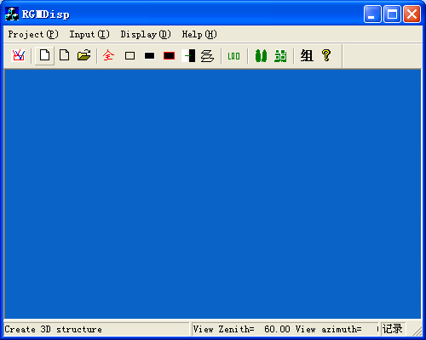
Click the second button in the toolbar, users can launch a dialog to create crop canopies.
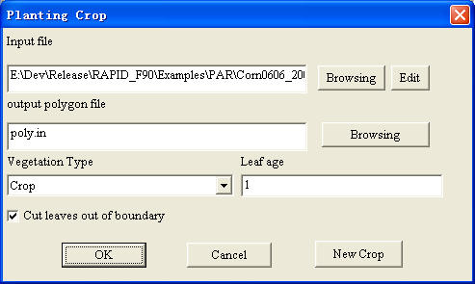
Click the “browsing” button to select a predefined parameter file (*.PAR). The “Edit” button can be used to modify the browsed file. “Leaf age” means a scale coefficient to enlarge or reduce the size of leaves. If you do not have a predefined *.PAR file, you can click the “new crop” button.
The format of a PAR file is as follows:
#------- canopy structures (unit:cm) --------
3 number of rows
8 max number of columns or clusters
1.83 LAI
15 row spacing (unit:cm)
5.0 column spacing (unit:cm)
0.0 soil roughness (unit:cm)
0.0 soil ridge height (unit:cm)
5.0 soil ridge width (unit:cm)
#--- cluster position (number of points, point 1, point 2.. point n)----
7 5 12 14 16 20 35 38 cluster in line 1
6 5 8 9 15 30 40 cluster in line 2
7 5 6 20 22 25 30 40 cluster in line 3
#------- plant structure-------
5 number of leaves per plant
10.1 Stem Zenith
20.000 Stem mean height(unit:cm)
2.0 Stem height roughness (standard deviation) (unit:cm)
0.1500 Stem radius bottom (unit:cm)
0.15000 Stem radius up (unit:cm)
# -------For each leaf, using x*(x-1) to fit the curve 二次曲线-------
# ID relative_height Length (cm) segement_angle curve shape leaf_width[0]-[5]
1 0.18 8.0 30 0.0 0.6 0.3 0.35 0.5 0.45 0.25 0
2 0.29 9.5 40 0.2 0.7 0.4 0.45 0.627 0.4 0.35 0
3 0.47 12.0 56 0.4 0.8 0.4 0.55 0.725 0.55 0.35 0
4 1.0 15 60 0.25 0.8 0.62 0.85 0.95 0.74 0.55 0
5 1.0 10.0 75 0 0.4 0.23 0.23 0.33 0.33 0.2 0

3.2 Interactively editing large scenes
A window program, Map Builder, is developed for user to plant trees, crop or other type of land cover over a specified terrain. The “setting” menu of “File” will first define the scene size and height range. The terrain menu (地形) can set different kinds of terrains, including plain ground, Gauss terrain, mountain ridges, valleys, and slopes.

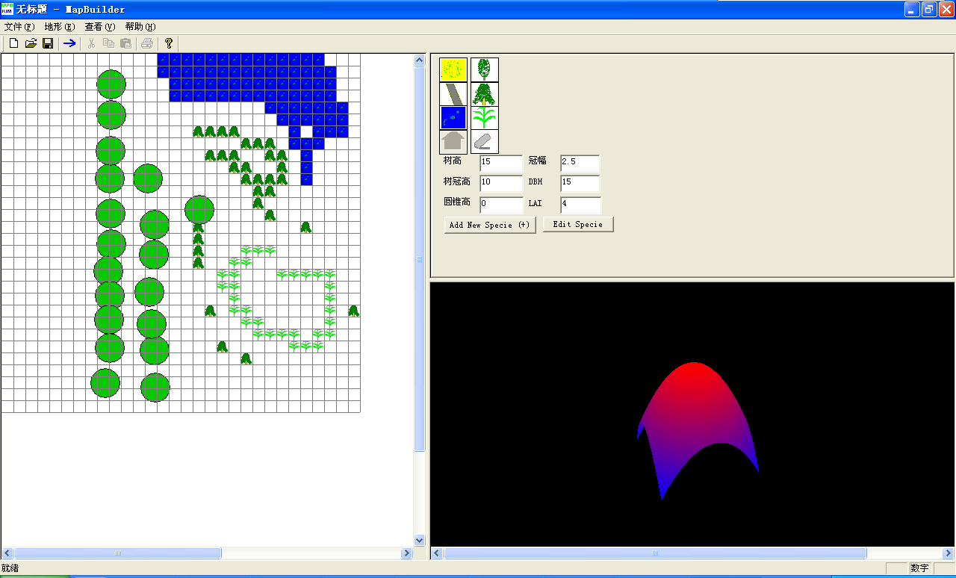
Click the first button can create a new project.
Click the second button can open an old project.
Click the third button can save current project.
To set water body, road, or bare soil on the grid, users can click the left buttons in the right top window to select a land cover.
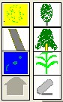
Then use mouse to click the grid to grow.
To plant trees or crops on the grid, users must click the right buttons in the right top window to select a tree crown type, which is ellipse, cone, or crop from top to down. Then, users must add new specie with specified plant height, radius, cone height, DBH, and LAI. If do so, a small button will appear along your selected crown type button. The maximum specie type for one crown type is nine, from 0 to 8.
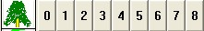
After clicking the button from 0 to 8, users can plant the specified tree on the grid now. A circle will appear on the grid to represent a plant. The circle radius is the plant crown radius.
Once users finished the editing, you can click the export button, which will transform the map file into POLY.IN.

3.3 Automatic generation using Matlab
A bunch of Matlab source codes is developed for users to generate POLY.IN. However, a few parametric files must be provided from users.
(1) Main file: default name as db_main.txt
input stand file:
pine_forest.dat
output polygon file:
poly.in
xmin xmax ymin ymax:
0 12 0 12
The main configuration file provides the input file name and output file name, as well as the boundary.

(2) input stand file:
# X, Y - tree coordinates within sample area.
# DBH - breast-height diameter, cm
# H - tree height, m
# L - crown length, m
# RCr - Crown radius, m
# Leaf_Proj - leaf area per tree, m^2
# Species codes:
# "MA" Pinus sylvestris
# "KS" Betula pendula
# "KU" Picea abies
#
#Stand Tree_ID Specium X Y DBH H LCR RCr Leaf_Proj
3935 1 "MA" 0.88 4.64 15.3 15.1 3.6 1.22 10.959
3935 2 "MA" 2.56 2.53 21.4 16.8 4.9 1.86 25.277
3935 3 "MA" 4.49 1.70 14.0 14.6 3.3 1.08 8.600
3935 4 "MA" 5.54 1.26 16.2 15.3 3.8 1.31 12.605
3935 5 "MA" 5.47 2.45 21.1 16.7 4.9 1.84 24.569
3935 6 "MA" 4.73 3.68 14.3 14.7 3.4 1.11 9.040
3935 7 "KS" 4.32 7.06 19.3 16.3 4.5 1.64 19.872
3935 8 "KU" 1.09 8.47 23.0 17.1 5.2 2.05 30.062
The input file is the one listed in the second line in the main configuration file. This input file contains the information of a forest stand or crop field. It is a ASCII table with ten columns: Stand ID, Plant ID, Plant specie, plant location X, plant Location Y, plant DBH, plant height, plant crown length, plant maximum crown radius, plant total leaf area. The symbol “#” represents a comment line.

(3) db_specie.txt
#TID CODE Crown Optics LAD description
1 'KS' 1 Abstract Sphere Plant
2 'LM' 2 Alnus glutinosa alder
3 'HB' 3 Populus tremula aspen
4 'MA' 4 Pinus sylvestris pine
5 'PN' 1 Tilia cordata
6 'SA' 1 Fraxinus excelsior
7 'VA' 2 Acer platenoides
8 'JA' 3 Ulmus glabra
9 'PJ' 3 Salix ssp.
10 'KU' 5 Picea abies spruce
11 'HM' 6 homo plant
This file tells the program the plant specie information, including the abbreviation, crown type, optics ID and name.

(4) db_crown.txt
1 (ellipsoid crown for hardwood like birch)
2 (cone crown for conifer trees like pine)
3 (cone crown for whirl conifer like spruce)
4 (ellipsoid crown for hardwood like peach)
5 (square cylinder)

This file defines the plant crown shapes.

(5) db_branch_angle.txt (optional)
1 35
2 45
3 30
4 20
5 20
6 10
This file defines the plant branch angles.

(6) db_leaf_optics.txt
1 0.35 0 0.35 0 0.15 0
2 0.35 0 0.35 0 0.15 0
3 0.35 0 0.35 0 0.15 0
4 0.18 0 0.23 0 0.27 0
5 0.25 0 0.28 0 0.32 0
6 0.35 0 0.35 0 0.15 0
This file defines the plant leaf colors using RGB with zero transmittances.

(7) db_bark_optics.txt
1 0.35 0 0.35 0 0.15 0
2 0.35 0 0.35 0 0.15 0
3 0.35 0 0.35 0 0.15 0
4 0.18 0 0.23 0 0.27 0
5 0.25 0 0.28 0 0.32 0
6 0.35 0 0.35 0 0.15 0
This file defines the plant bark colors using RGB with zero transmittances.

(8) db_stem_optics.txt
1 0.5 0 0.5 0 0.2 0
2 0.4 0 0.4 0 0.2 0
3 0.4 0 0.4 0 0.1 0
4 0.29 0 0.33 0 0.41 0
5 0.22 0 0.24 0 0.25 0
6 0.5 0 0.5 0 0.2 0
This file defines the plant stem colors using RGB with zero transmittances.

(9)db_shoot.txt
0.077 0.003 (shoot length and diameter)
190 (needle number)
0.0285 0.00092 (needle length and diameter)
40.5 (needle inclination angle)
1 (optical id refer to db_leaf_optics.txt)
This file defines the plant shoot structure.

4. Temperature file generation
Use ECupid.exe or manually edit the tc.in (for RAPID) or thermal.in (for TRGM).

5. Model Run
- Run RGMDisp.exe
- Click File->new project ;
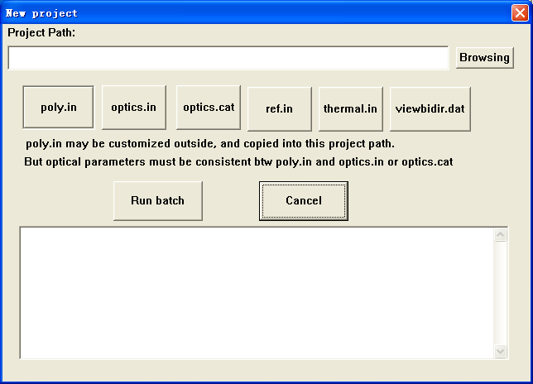
- Click the button “browsing” to select a folder to run your case ;
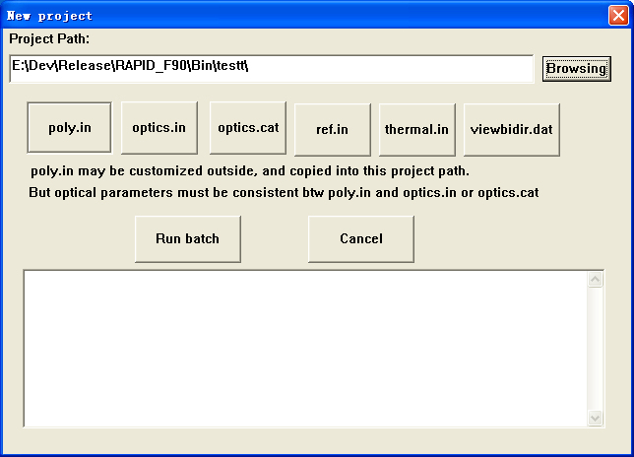
- Click the button “POLY.IN” to create a 3D structural file of crop canopies;
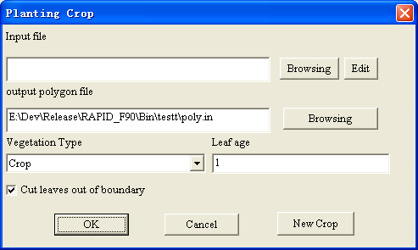
The input parameters for 3D scene has a suffix “*.par”, describing the rows, plants, spacing of row of column, leaf numbers, LAI, crop height, stem radius and so on. It is a text file. Please find some examples to learn it. Details are also described in section 3.1.
NOTE: section 3.2 and 3.3 can also be used to create POLY.IN.

- Click the other buttons to modify model parameters:
Ref.in: sun zenith or azimuth angles, sky diffuse ratios;
Viewbidir.dat: viewing zenith or azimuth of sensor;
tc.in: store the leaf, soil temperatures;
Optics.cat: to identify the class of each polygon in POLY.IN;
Optics.in: to give the reflectance or transmittance for all component classes.

- Click “Run batch” to run the model. The results will be stored in the project folder. The running information on the textbox can be used to check if the programs are correctly done.

Manually running is available by entering the folder you browsed for your case. There is a bat file “*.bat” stored the steps to run the model. You can run the command line by line at a DOS prompt.

6. Visualization of RAPID results using RGM Displayer
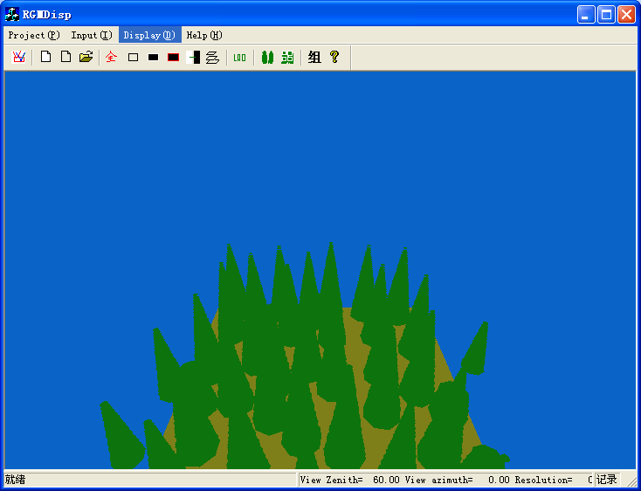
- Run RGMDisp.exe
- Click Project->open scene to open a POLY.IN.
- Click Display->set view angle to set the view direction;
- Users can try the other sub-menus under Display to see what happens.
Left Mouse on the screen can pan and rotate the scene. Left or right Arrows change the view azimuth or rotation angles. Up or down arrows move forward or backward. Page Up or Down change the view zenith.

7. FAQ
1. Where can I find some related literature?
- Huaguo Huang, Wenhan Qin, Qinhuo Liu, 2013, RAPID: A Radiosity Applicable to Porous IndiviDual Objects for directional reflectance over complex vegetated scenes, Remote Sensing of Environment, Volume 132(5): 221-237 (SCI, IF = 4.57)
- Huang H. G., QIANG LIU, QIN HUO LIU, and WEN HAN, 2012, Validating theoretical simulations of thermal emission hot spot effect on corn canopies, International Journal of remote sensing, 33(3):1-16 (SCI, IF = 1.15)
- Huang, H., Q. Liu, W. Qin, Y. Du, and X. Li, 2011, Temporal patterns of thermal emission directionality of crop canopies, J. Geophys. Res., 116, D06114, doi:10.1029/2010JD014613. (SCI, IF = 3.3)
- Huang Huaguo, Dou baocheng, and Hu Ni, 2011, Tassel effect on the thermal emission directionality of corn canopies [J]. Hongwai Yu Haomibo Xuebao/Journal of Infrared and Millimeter Waves, 30(2):120~123 (SCI, IF = 0.45)
- Huaguo Huang, Qinhuo Liu; Wenhan Qin, 2010, Thermal Emission Hot Spot Effect of Crop Canopies—Part I: Simulation, IEEE JSTARS, 3(3): 313 - 322 (SCI, IF = 1.14)
- Huaguo Huang et al., 2009, A realistic structure model for large-scale surface leaving radiance simulation of forest canopy and accuracy assessment. International Journal of remote sensing, 30(20): 5421 – 5439 (SCI, IF = 1.04)
- Qinhuo Liu, Huaguo Huang, Wenhan Qin, KaiHua Fu, Xiaowen Li. (2007). An Extended 3-D Radiosity–Graphics Combined Model for Studying Thermal-Emission Directionality of Crop Canopy. IEEE Transactions on Geoscience and Remote Sensing. 45(9): 2900-2918 (SCI, IF = 2.34)
- Feng Zhao, Xingfa Gu, Wout Verhoef, Qiao Wang, Tao Yu, Qiang Liu, Huaguo Huang, Wenhan Qin, Liangfu Chen, Huijie Zhao, A spectral directional reflectance model of row crops, Remote Sensing of Environment, Volume 114, Issue 2, 15 February 2010, Pages 265-285, ISSN 0034-4257, 10.1016/j.rse.2009.09.018. (SCI, IF =3.61)
- Huang, Huaguo, Xin, Xiaozhou, Liu, Qinhuo, Liu, Qiang, Chen, Liangfu, Li, Xiaowen. Modeling soil component temperature distribution by extended CUPID model. Nongye Gongcheng Xuebao/Transactions of the Chinese Society of Agricultural Engineering, v 23, n 1, p 139-145, January 2007 (EI)
- Huang, Hua-Guo, Liu, Qin-Huo, Liu, Qiang, Du, Yong-Ming, Li, Xiao-Wen. Simulation of time effect on thermal emission directionality measurement. Xitong Fangzhen Xuebao / Journal of System Simulation, v 19, n 15, p 3586-3590, Aug 5 2007 (EI)
- Huaguo Huang, Research on simulating temperature distribution of typical crop canopies. Ph.D thesis of Chinese Academic of Sciences. 2007 [黄华国.典型农作物冠层温度分布模拟研究.[博士学位论文].中国科学院研究生院.2007-05]

